Varsity College Durban North

**APDS7311.** **POE. Part 2**

2023

by

Jordan Green

Student Number: st10083222

St10083222@vcconnect.edu.za

Part 2:

GET

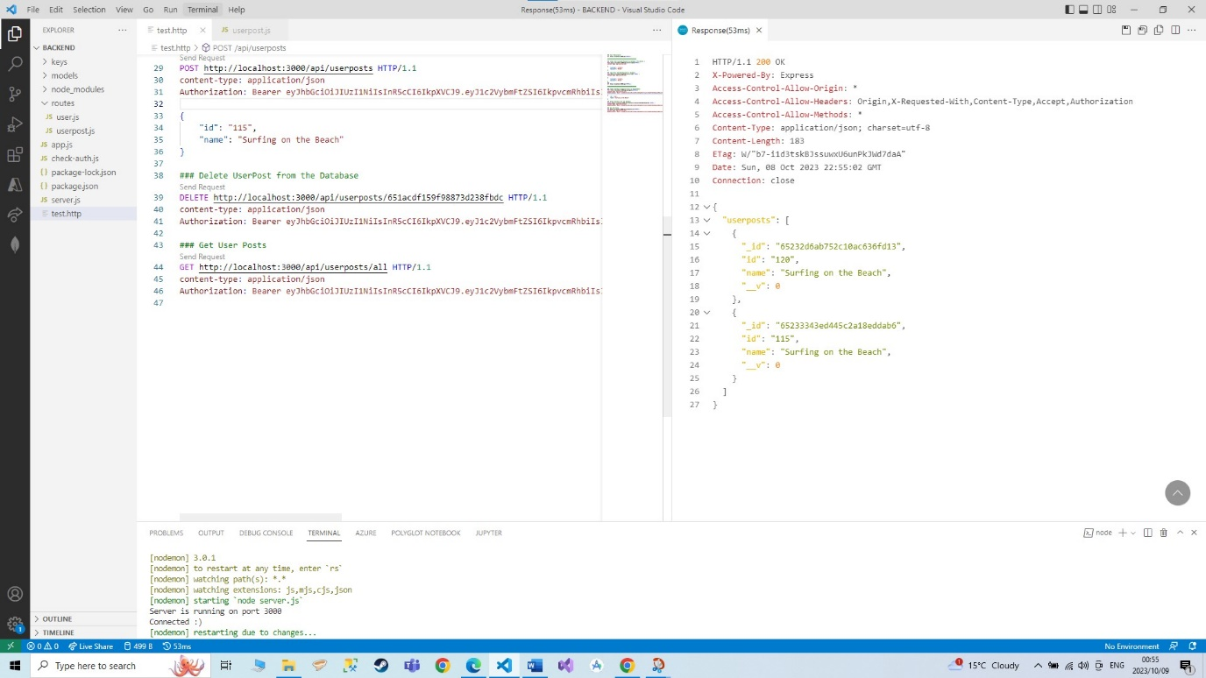

CREATE

DELETE

REGISTER A NEW USER

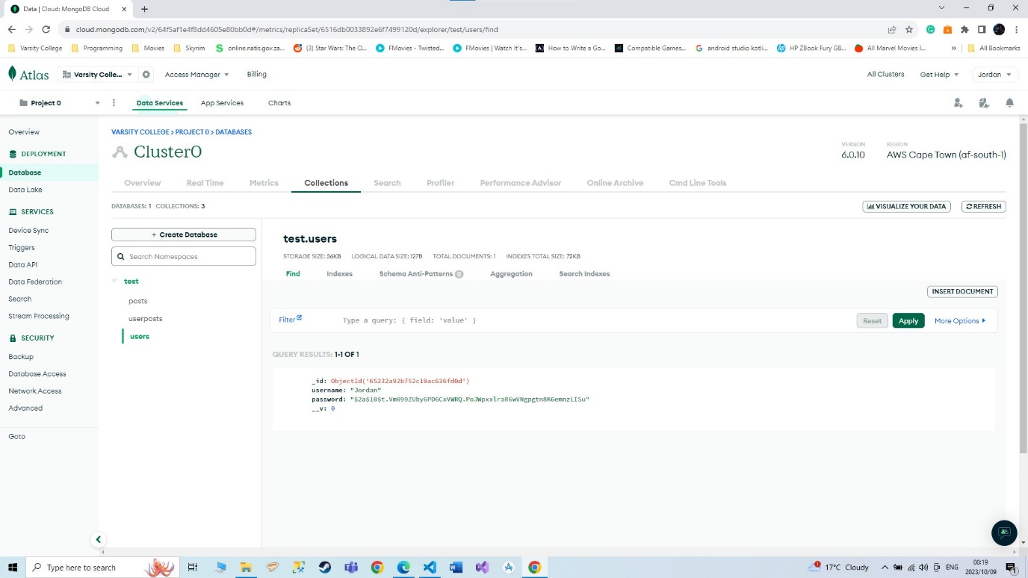

LOGON A USER

# References

The Independent Institute of Education. (2021). *APDS7311 LAB GUIDE 2023 (First Edition: 2021),* pg: 4, 11, 16, 33, 41, 44 (Vol. 1). Retrieved October 7, 2023